**Real-time Laptop Camera Alarm System**

**Authors: Lei Zhang**

**Ruicheng Fan**

**Date:12/13/17**

**Abstract**

Alarm system is based on Matlab GUI interface. Using buttons control panel and camera input to show real-time monitor environment. If the images from the camera changes, it will be compared which are acquired from Otsu threshold method. What’s more, the images are converted into binary images and if any difference is detected, the monitor alarm will run and send e-mails to the user. It’s the SMTP technique that play an important role. In addition, a warning alarm function based on keyboard press detection and password function is designed. Once the intruder tries to press any keys, a warning sound will not stop until the alarm is closed through the password system.

**Introduction**

In our daily life, there is possibility that our laptop is touched or even stolen by someone when we leave the laptop alone in library. In order to prevent our laptop in danger under this circumstance, we design the alarm system based on Matlab GUI which is easy to build and realize applications. All this project is based on mac operating system and Matlab2016b.

1.Matlab GUI

Matlab GUI(Graphical User Interface) provides an easy control of software applications and only need to download some toolboxes. Matlab itself provides a guide that you can design the Matlab GUI in custom ways. In the guide menu, Matlab can create some initialization and settings codes automatically after designing your own buttons [2]. And then you can apply function codes into each buttons. If typing “imaqhwinfo” in Matlab console, you will get the basic camera information. And if typing vid = videoinput('macvideo',1), you can get the important parameters like “TriggerRepeat”, “FramesPerTrigger” and “FrameGrabInterval”.

2.Otsu threshold Method

The basic idea of Otsu threshold method: Reduction of a graylevel image to a binary image [3]. The algorithm assumes that the image contains two classes of pixels (foreground pixels and background pixels), it then calculates the optimum threshold separating the two classes so that their intra-class variance is minimal. We use Otsu to process the images of different time. Then Compare the current binary image and next frame’s binary image. If the difference is larger than the threshold, we will design to make a snapshot. In Matlab, we use “graythresh()” and “im2bw(frame,level)” to get the threshold and binary image respectively.

3. Send e-mail using SMTP

SMTP stands for Simple Mail Transfer Protocol. SMTP is used when email is delivered from an email client, such as GMail, to an email server or when email is delivered from one email server to another [1]. In order to send e-mails from Matlab, we have to give the Matlab the authority to access our email account (we are using Gmail in this function). In other words, use SMTP in Matlab and open access to Matlab from Gmail. In this way can we send the emails from matlab to the selected mailbox with the snapshot.

4. Warning alarm system

Matlab can play audio file and detect key press. So we combine these two functions and design a warning system which can detect keyboard press. Playing warning sound is quite simple by using “audioread”. Keyboard detection can be realized through creating a dependent key press function. Once the key press is detected, the warning sound will be played unstoppably. In this way can the intruder be warned to leave, once the alarm is activated.

5. Password system

the alarm system can be activated if the conditions are satisfied. However, in order to avoid the situations that the intruder can close off the warning system, we design the password system on the “stop alarm” and “exit” buttons. The password system is based on an input dialog using “inputdlg” and set password verification which also provides the message whether the password is correct or not. What’s more, the password can be set by the user from a-z, 0-9 which is difficult to be cracked.

**Result and discussion**

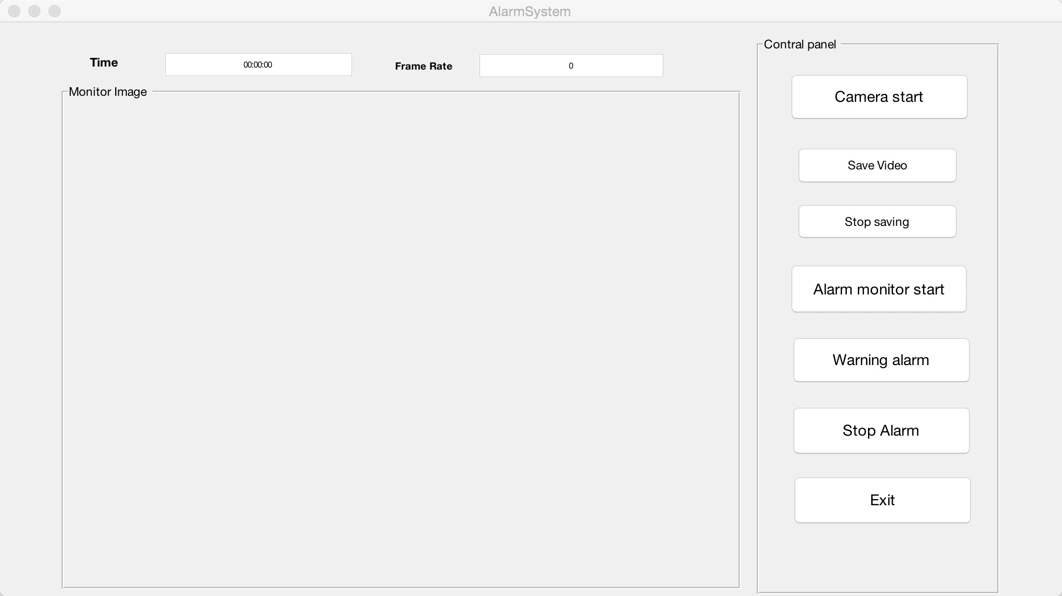

figure1



figure2

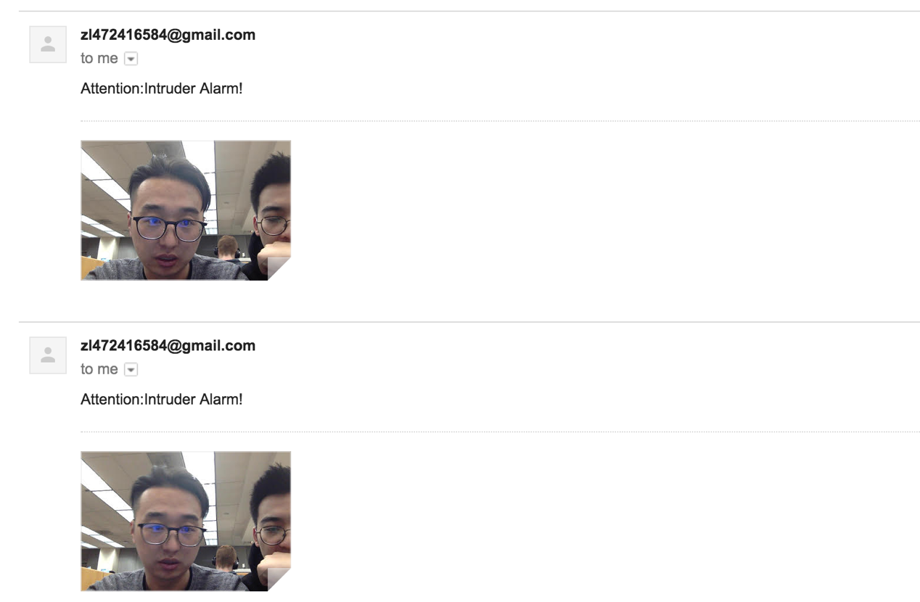

figure3

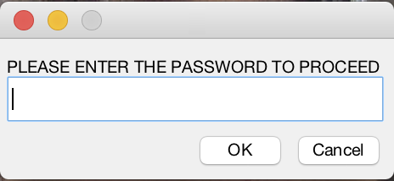

figure4

The Matlab GUI control panel is showed above in figure1. I will introduce these buttons from top to bottom. Firstly, click the “Camera start” button and the camera will start and show real-time video in the left box of “Monitor image”. If click other buttons before click “Camera start”, a message box with “please start camera” will appear. Then the “save video” and “stop save” buttons are designed to save videos. Initially we want to save the video and send it to us via e-mail, but we find that the video will not run fluently and the file of video is too big to send. In the end, after discussion we still keep this function for future use. Thirdly, click the “Alarm monitor start”, the alarm system will start and nothing will happen if nobody appears in front of the camera. But if somebody appears(figure2), the camera will keep taking snapshots and sending it to the selected mailbox(figure3). After a while, the user can check the emails by cellphone and see the photos of the intruder. And after that, if the intruder presses the keyboard, the warning sound will be played. It’s the “warning alarm” button which sets the function and makes it effective. If the Intruder want to stop the alarm or quit the program, after clicking either buttons, a password dialog will appear(figure4). Only the correct password can pass the dialog, and the wrong passwords can keep the alarm still running. Last button “exit” can quit the program after entering the correct password.

**Summary and conclusion**

Through Matlab GUI interface, we are able to set the functions and realize applications by using control buttons. The main task is basing connection between the application and control buttons. In other words, designing and testing functions is the main object. This project mainly contains 4 functions: video save, alarm monitor using email, keyboard press warning system, password protection. After Finding out the basic information of laptop camera and setting the proper parameters, real-time images can be shown through the GUI window. From then on, alarm monitor is designed through Ostu’s threshold method. This method converts the images into binary images. After a quantity number of times experiences, the best threshold can be determined. And if the images changes are beyond this threshold, the alarm system will get into work. At the same time, e-mails can be sent to the user with the snapshots of the intruder. The premise is the authentication has been got from the Gmail service through Matlab. And the email is sent using SMTP method which represents for simple message transportation protocol. What’s more, if the intruder tries to press keyboard, the warning sound will be played. This function is based on a key-press-detection function. And also the alarm monitor and keyboard press warning system are protected by the password system. If the intrude wants to close the either of the alarm, a dialog using password protection will eject out. Unless the correct password is entered, the alarm will still be running.

All in all, a real-time laptop camera alarm system controlled by a Matlab GUI panel has been realized and all applications can run automatically. Some knowledge about JAVA, internet protocols, Matlab functions are acquired from outside class. The progress of learning these knowledge and debugging programs is painful but interesting. Although the functions that the project achieved are not so complete, this alarm system can certainly work well and protect the laptop which meets the initial demand.

**Reference**

[1]: https://en.wikipedia.org/wiki/Simple_Mail_Transfer_Protocol

[2]:https://www.mathworks.com/matlabcentral/fileexchange/24861-41-complete-gui-examples

[3]: <http://www.labbookpages.co.uk/software/imgProc/otsuThreshold.html>